Approval Signatures:

Department | Name | Signature | Date
QA | Andrea Miller
OPS | Michael Stowell
Exec | Nancy Rizzo
IS | Andrew Mason

- Purpose

This document is intended to provide a protocol for use in validating the Report Icon within ClearView ™ software. This protocol is intended to provide a method for conducting the testing as well as to be used as a formal record of the validation activities.

- Scope

This protocol is intended to be used to fully validate the REPORT icon portion of the ClearView software for use. The protocol can be executed in total or in part. Any deviation from performing all sections of this validation must be resolved with appropriate written justifications prior to final approval of the validation report. The verification that the reported data (e.g., reported response scale values, Biofields tab display, NS values in the NS tab, etc.) is accurate will be performed in a separate protocol(s).

- Definitions

N/A

- Responsibilities

User | - Complies with the policy and procedure.  - Ensures the most current version of this document is used when referenced.
Departmental Management | - Ensures departmental personnel are properly trained before using this policy or procedure.  - Provides oversight to the validation process and ensures that all quality system requirements are met.
Quality Assurance | - Monitors the implementation and effectiveness of this document.  - Audits to ensure compliance with the referenced procedures

- Policy

  - This protocol is intended to be updated for any changes made to the software such that the instructions provide a comprehensive test to demonstrate whether the software meets the intended use. Validation of the technical analyses and mathematical computations are completed under a separate protocol.
  - Follow the instructions provided within this protocol as written. Any deviations from the written protocol will be recorded on Attachment A, Deviations from Protocol.
    - An individual will be assigned responsibility from the Validation Team to oversee the execution of the protocol. This validation designee will review each deviation as documented prior to moving forward in the validation process.
    - The validation designee will be required to determine whether the deviation requires formal documentation through EPIC’s Deviation procedure or if the deviation is minor enough to warrant documentation only.
    - Upon completion of the protocol, the Validation Team has the responsibility to review all deviations recorded to determine whether or not they significantly impact the protocol/validation process. Any deviation deemed significant will be handled through EPIC’s Deviations procedure.
    - The individual performing the validation protocol will complete each column of Attachment A for all deviations from the written protocol prior to moving forward. The validation designee will review each deviation prior to moving forward in the validation process. This review is indicated by documenting a signature and date in the Review column of the Deviations from Protocol worksheet located in Attachment A.
    - The validation designee should be aware during the execution of this validation protocol that the intention is to validate all functionality of the PATIENT Icon. If at any time a portion of the software is identified as not being challenged notify the validation team immediately and document the omission on the non-conformances worksheet.

  - The written protocol is intended to capture the steps needed to properly challenge each software function/data point. However, given the evolving nature of software development, the instructions may not be 100% accurate. Therefore, any minor deviation from the written instructions will be corrected in writing during the execution of the validation protocol. These corrections will be reviewed by QA as a part of the validation analysis. The review will determine appropriate corrective and preventive action for any deviations notes.

  - Record the results of each validation step by initialing and dating in the space provided. If the characteristic cannot be verified, record a reference number on the protocol and the Non-Conformances Worksheet (Attachment B) and describe the failure in a specific and complete manner by completing all columns on the Non-Conformance Worksheet. Some validation steps ask the validation designee to record the results side-by-side. In these cases, record initials and date on each side of the slash mark after validating each step as instructed.

  - ClearView Error Messages
The three acceptable error messages generated by the ClearView software are shown below. If any other error message is displayed during the execution of this protocol, describe and record the error on the Non-Conformances Worksheet.








- Procedure
  - Device Set Up

    - Verify with QA and IT that the correct ClearView software revision, license, database, and scanner have been installed on the test workstation.
    - Clean the glass lens with isopropyl alcohol and the provided cloth. Dry the glass lens completely with a separate dry cloth.
    - Place the calibration shroud over the lens cover.
    - Clean the metal cylinder of the calibration probe with isopropyl alcohol and the provided cloth. Dry the calibration probe completely with a dry cloth.
    - Place the calibration probe, metal cylinder first, through the opening of the calibration shroud until the bottom of the probe sits flat on the glass lens.
    - Double click on the ClearView software icon located on the computer desktop. This will open the ClearView software and present the “Login As” window.
    - The version of the ClearView software is displayed across the top header of the software. Record the software version being validated:

_______________________________________________________

  - “Login As” function- This window provides the user a method to enter their user name and password in order to access the ClearView software application.

Double click the EPIC ClearView icon on the desktop. Click in the Username box and enter “Administrator”. Click in the password box and enter the password provided by the Network Administrator. The EPIC ClearView main screen is displayed.

NOTE: The ClearView software is divided into three levels: tabs, subtabs, and categories. These levels will be referenced throughout this document. 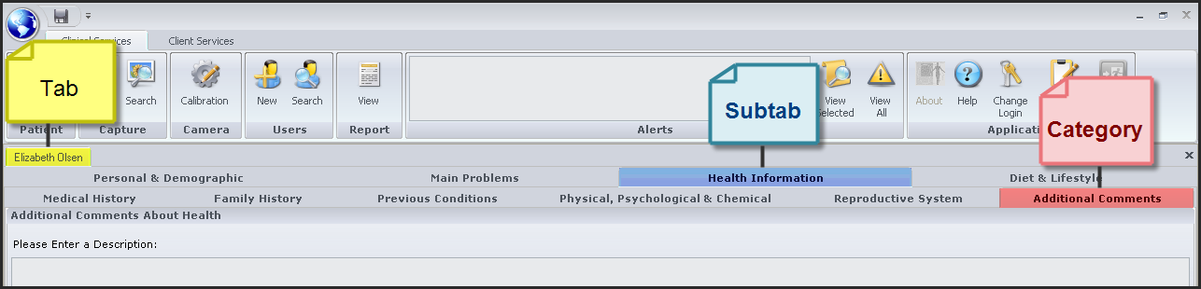
  - “Report” icon.

    - View Report Button. Click the View Report button. Verify that the Report Menu is displayed and that “Analysis Report” is highlighted.

Verified Not Verified Non-Conformance Ref. No.

Click the Display Report button at the bottom right of the Report Menu box. Verify that the Search Capture window is displayed.

Verified Not Verified Non-Conformance Ref. No.

The Search Capture functionality for “New Capture” and “View Capture” will be validated in a separate protocol. No further challenge for these buttons is required.

View Calibration button

Click on the View Calibration button. Verify that the Search Capture window remains open without further changes.

Verified Not Verified Non-Conformance Ref. No.

View Capture button

Click on the View Capture button. Verify that the Search Capture window remains open without further changes.

Verified Not Verified Non-Conformance Ref. No.

View Report button

Click on the View Report button. Verify that the Search Capture window remains open without further changes.

Verified Not Verified Non-Conformance Ref. No.

Export Data

Click on the Export Data button. Verify that the Search Capture window remains open without further changes.

Verified Not Verified Non-Conformance Ref. No.

    - Exporting Data

Type “V” in the last name box of the Search Capture box. Click Find. Highlight Epic O. Validation with Treatment ID 2185. Click the Export Data button. Verify that the Browse for Folder window opens.

Verified Not Verified Non-Conformance Ref. No.

Locate folder O:\QualitySystems\Quality_System_Documents\Non-quality_system_records\1.1.1.2_Validation. Click OK. Verify that the Information dialog box opens with the message “The export process is complete.” Click OK.

Verified Not Verified Non-Conformance Ref. No.

Click the “X” in the upper right hand corner of the Search Capture screen. Click the “-” in the upper right corner of the ClearView main screen to minimize ClearView and to display the Desktop. Click on My Computer and locate folder O:\QualitySystems\Quality_System_Documents\Non-quality_system_records\1.1.1.2_Validation. Verify that under 1.1.1.2_Validation the folder Validation_6_3_2011_9_12_56_PM was created.

Verified Not Verified Non-Conformance Ref. No.

Verify that the following folders were created under
Validation_6_3_2011_9_12_56_PM:

AdminData
CalibrationData
CalibrationImages
EnergizedImages
FingerImages
RawData
ReportData

Verified Not Verified Non-Conformance Ref. No.

Click to open folders AdminData, CalibrationData, RawData, and ReportData and verify that .csv files were created under each folder with the same name as folder.

Verified Not Verified Non-Conformance Ref. No.

Open the CalibrationImages folder and verify that it contains ten (10) .bmp files (one for each finger) in the following format:

1L_CalibrationImage#6.bmp
1R_CalibrationImage#1.bmp
2L_CalibrationImage#7.bmp
2R_CalibrationImage#2.bmp
3L_CalibrationImage#8.bmp
3R_CalibrationImage#3.bmp
4L_CalibrationImage#9.bmp
4R_CalibrationImage#4.bmp
5L_CalibrationImage#10.bmp
5R_CalibrationImage#5.bmp

Verified Not Verified Non-Conformance Ref. No.

Open the EnergizedImages folder and verify that it contains twenty (20) .bmp files (one for each finger _filter, and one for each finger _wofilter).

Verified Not Verified Non-Conformance Ref. No.

Open the FingerImages folder and verify that it contains twenty (20) .bmp files (one for each finger _filter, and one for each finger _wofilter).

Verified Not Verified Non-Conformance Ref. No.

Click on the taskbar to maximize ClearView. Verify that the screen returns to the ClearView main screen.

Verified Not Verified Non-Conformance Ref. No.

    - Admin Pages tab

Type “V” in the last name box of the Search Capture box. Click Find. Highlight Epic O. Validation with Treatment ID 2185. Click View Report button. Verify that a report appears on the screen, that the Print Report tab for patient EPIC Validation is highlighted and the Print Report subtab is open.

Verified Not Verified Non-Conformance Ref. No.

Verify that the following tabs are listed in the gray bar just below the icons:
Worksheet for Epic Validation
NS Analysis for Epic Validation
Admin pages for Epic Validation
BioField Analysis for Epic Validation
Print Report for Epic Validation

Verified Not Verified Non-Conformance Ref. No.

Verify that when the Admin Pages tab is highlighted, five subtabs as listed below are visible:
Raw Data (open)
Raw Report Data
Images without Capacitive Barrier
Images with Capacitive Barrier
Calibration Data

Verified Not Verified Non-Conformance Ref. No.

Verify that the open Raw Data subtab contains multiple columns and rows of data and the cells are not editable.

Verified Not Verified Non-Conformance Ref. No.

Click on the Raw Report Data subtab. Verify that two tables with multiple columns and rows of data appear and the cells are not editable.

Verified Not Verified Non-Conformance Ref. No.

Click on the Images without Capacitive Barrier subtab. Verify that one set of images appears – 10 Images without Capacitive Barrier.

Verified Not Verified Non-Conformance Ref. No.
#7
#6
#5
#4
#3
#2
#1
Click on the Toggle Sectors button in the lower left corner of the screen. Verify that multiple intersecting lines and numbers appear on each image. Click on the Toggle Sectors button. Verify that the lines and numbers disappear.

Verified Not Verified Non-Conformance Ref. No.

Click on the Images with Capacitive Barrier Scan Images subtab. Verify that one set of images appears – 10 Images with Capacitive Barrier.

Verified Not Verified Non-Conformance Ref. No.
#7
#6
#5
#4
#3
#2
#1
Click on the Toggle Sectors button in the lower left corner of the screen. Verify that multiple intersecting lines and numbers appear on each image. Click on the Toggle Sectors button. Verify that the lines and numbers disappear.

Verified Not Verified Non-Conformance Ref. No.

Click on the Calibration Data subtab. Verify that one set of images appears – 10 Calibration Images.

Verified Not Verified Non-Conformance Ref. No.

    - Worksheet for Epic Validation tab (where Epic Validation is the patient name)

Click the Worksheet tab on the gray bar below the icons. Verify that the table displayed on the right side of the tab has column headings of Organ, Physical Systems (both Left Hand and Right Hand) and an Autonomic Systems (both Left Hand and Right Hand) and that data (numbers) are present in the Physical System and Autonomic System table.

Verified Not Verified Non-Conformance Ref. No.

Verify that a listing of the Organ Systems is displayed on the left side of the tab. Verify that the Organ Systems listed have a check mark inside the box and that the systems listed are as follows:

Gastrointestinal System
Hepatic, Endocrine, and Nervous System
Sensory and Skeletal Systems
Cardiovascular System
Respiratory System
Renal and Reproductive Systems

Verified Not Verified Non-Conformance Ref. No.

Verify the Scan Details box appears below the Organ Systems box, and contains entries for Patient Name, Scan Date (including time), Software and Firmware. Click on the Search Capture button. Click the Find button in the Search Capture window. Locate and highlight Treatment ID 2185. Verify the Name, Scan Date, and Software highlighted match the entries in the Scan Details box. In the Search Capture window, locate and highlight the original scan (this is the ID listed in the Run Notes column next to Reprocessing of Treatment ID). Verify the Scan Date (including time) of the original scan matches the Scan Date (including time) of Treatment ID 2185. Verify the Firmware is listed as Revision E on the Worksheet tab.

Verified Not Verified Non-Conformance Ref. No.

Click the “Use color coding for organ systems” box just below the Organ Systems block. Verify that the names of the organ systems and organs are now color coded by system (i.e. Cardiovascular System is now gold in the Organ Systems box and Circulation, Coronary Vessels, Heart, etc., are also gold).

Verified Not Verified Non-Conformance Ref. No.

Click on each of the boxes in the Organ systems block to remove the check mark. Verify that there are no organs listed in the Physical and Autonomic System tables.

Verified Not Verified Non-Conformance Ref. No.

Click to check the Gastrointestinal System box. Verify Gastrointestinal is purple and the following organ names are purple in color and listed in the Physical and Autonomic System table:

Abdominal Region
Appendix
Ascending Colon
Blind Gut
Descending Colon
Duodenum
Ileum
Jejunum
Rectum
Sigmoid Colon
Transverse Colon

Verified Not Verified Non-Conformance Ref. No.

Deselect the Gastrointestinal box in the Organ Systems block. Click to check the Hepatic, Endocrine and Nervous System box. Verify Hepatic is green and the following organ names are green in color and listed in the Physical and Autonomic System table:

Cerebral Cortex
Cerebral Vessels
Gallbladder
Hypothalamus
Immune System
Liver
Nervous System
Pancreas
Pineal
Pituitary
Spleen
Thyroid

Verified Not Verified Non-Conformance Ref. No.

Deselect the Hepatic in the Organ Systems block. Click to check the Sensory and Skeletal Systems box. Verify Sensory and Skeletal is red and the following organ names are red in color and listed in the Physical and Autonomic System table:

Cervical Spine
Coccyx/Pelvis
Ear/Nose/Sinus (L)
Ear/Nose/Sinus (R)
Eye (L)
Eye (R)
Jaw/Teeth (L)
Jaw/Teeth (R)
Lumbar Spine
Sacrum
Thoracic Spine

Verified Not Verified Non-Conformance Ref. No.

Deselect the Sensory and Skeletal Systems box in the Organ Systems block. Click to check the Cardiovascular Systems box. Verify Cardiovascular is gold and the following organ names are gold in color and listed in the Physical and Autonomic System table:

Cardiovascular Circulation
Cervical Vascular System
Coronary Vessels
Heart – (Left Side)
Heart – (Muscles)
Heart – (Right Side)

Verified Not Verified Non-Conformance Ref. No.

Deselect the Cardiovascular box in the Organ Systems block. Click on the Respiratory System box. Verify the Respiratory color is blue and the following organ names are blue in color and listed in the Physical and Autonomic System table:

Respiratory/Mammary
Thorax Respiratory

Verified Not Verified Non-Conformance Ref. No.

Deselect the Respiratory box in the Organ Systems block. Click on the Renal and Reproductive Systems box. Verify the Renal color is light blue and that the following organs are light blue in color and listed in the Physical and Autonomic System table:

Adrenal
Genitourinary System
Kidney – Left
Kidney – Right
Urokidney

Verified Not Verified Non-Conformance Ref. No.

Click to check the Gastrointestinal, Hepatic, Sensory, Cardiovascular, Respiratory and Renal boxes. Verify that all boxes in the Organ System block are checked.

Verified Not Verified Non-Conformance Ref. No.

Verify that all organs are listed in the Physical and Autonomic System table and that all are properly color coded.

Verified Not Verified Non-Conformance Ref. No.

Click to uncheck the “Use color coding for organ systems” box below the Organ Systems block. Verify that all color coding has been removed.

Verified Not Verified Non-Conformance Ref. No.

    - NS Analysis for Epic Validation tab (where Epic Validation is the patient name)

Click on the NS Analysis tab for “Epic Validation” in the gray bar below the icons. Verify that two boxes with a skeleton graphic is displayed surrounded with graph lines around each one.

Verified Not Verified Non-Conformance Ref. No.

Further verification of the displayed NS values will be conducted in a separate protocol.

    - Biofield Analysis for Epic Validation tab (where Epic Validation is the patient name)

Click on the Biofield Analysis for “Epic Validation” tab in the gray bar below the icons. Verify that three body images appear and that the Item Data subtab is open, with boxes labeled “Indexes”, “Organ Systems” and “Settings”, and an image box below with the subtabs Magnified View (open) and Admin View.

Verified Not Verified Non-Conformance Ref. No.

Under Settings, click the button next to “Autonomic” to choose the “Unfiltered” system (Images without Capacitive Barrier). Under Organ Systems, click on each of the radio buttons to display different organ systems. Verify that the CT scans and portions of scan images change for each organ system. Document the verification in the table below by placing your initials in the appropriate column.

Organ | Verified Unfiltered | Non-Conforming? | Ref. No.
Skeletal System
Cardiovascular System
Small Intestine
Large Intestine
Renal & Reproductive
Head & Upper Back
Lower Back
Immune System
Respiratory System
Nervous System

Repeat for the “Physical” or “Filtered” system (Images with Capacitive Barrier)
Organ | Verified Filtered | Non-Conforming? | Ref. No.
Skeletal System
Cardiovascular System
Small Intestine
Large Intestine
Renal & Reproductive System
Head & Upper Back
Lower Back
Immune System
Respiratory System
Nervous System

      - Five samples will be randomly selected from development test subjects. The ClearView Reports for these randomly selected individuals will be printed and used in the verification. This data will be referred to as the Reference Data for subsequent steps. Record results on Attachment C.

NOTE: A sample size of 5 was selected as this verification is to ensure that the software is pulling data from the database accurately in a repeatable method. The data is not actually being calculated for display, but instead is being sourced from the database. The verification of the accuracy of the calculation will be documented in a separate validation protocol.

      - The reference data results will be compared to the Biofield Analysis report tab in the ClearView software. The data points compared for each sample are as follows:

      - Organ Systems- Compare each organ system listed on the Reference Data ClearView Report to ensure that the proper organs are listed in the Organ Systems section of the Biofield Analysis tab. This verification is done once as the systems are the same for all subjects.

      - Item Data- For each sample, verify the following:

        - Verify that the Physical and Autonomic reported values of Right Index and Left Index are displayed accurately for each organ within all organ systems.

NOTE: Several organs within the Skeletal Organ System are titled differently in the Biofield Analysis display. These structures include the shoulder, hip, knee and ankle. In order to verify these structures, the finger/sector displayed in the Admin View will be used to ensure that the proper organ system is being compared.

      - Verify that the Color Enhanced button when selected displays a color version of the image in the box on the left of the screen. See example below.

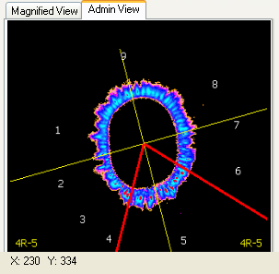
Figure 1

      - Verify that the B&W button when selected displays a black and white version of the image in the box on the left of the screen. See example below.

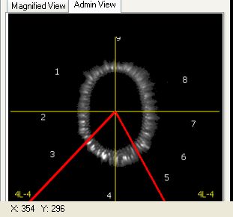
Figure 2

      - Verify that the finger/sectors match the organ for all organ systems. Note: finger/sector displayed in the bottom left and right corners of the Admin View in Figure 2 above.

Sector | Organ |  | Sector | Organ
1L-7 | Eye (L) |  | 1L-4 | Cervical Vascular System - Left
1R-1 | EYE (R) |  | 1R-4 | Cervical Vascular System - Right
1L-6 | Ear, Nose, Sinus (L) |  | 5L-6 | Coronary Vessels
1R-2 | Ear, Nose, Sinus (R) |  | 5R-6 | Coronary Vessels
1L-5 | Jaw, Teeth (L) |  | 5R-5 | Heart (muscle)
1R-3 | Jaw, Teeth (R) |  | 5L-1 | Heart (Left Side)
2L-8 | Cervical Spine |  | 5L-5 | Heart (Right Side)
2R-1 | Cervical Spine |  | 3L-1 | Cardiovascular Circulation  (whole body) - Left
2L-7 | Thoracic Spine |  | 3R-6 | Cardiovascular Circulation  (whole body) - Right
2R-2 | Thoracic Spine |  | 5R-1 | Duodenum
2L-6 | Lumbar |  | 5L-4 | Jejunum
2R-3 | Lumbar |  | 5R-2 | Ileum
2L-5 | Sacrum |  | 2R-6 | Blind Gut
2R-4 | Sacrum |  | 3L-4 | Abdominal Region
2L-4 | Coccyx / Pelvis |  | 4R-2 | Thyroid
2R-5 | Coccyx / Pelvis |  | 4L-7 | Thyroid
4L-2 | Nervous System |  | 4L-6 | Pancreas
4R-7 | Nervous System |  | 4R-3 | Pancreas
4L-1 | Hypothalamus |  | 3L-3 | Liver
4R-8 | Hypothalamus |  | 3R-4 | Liver
4L-8 | Pituitary |  | 3R-3 | Gallbladder
4R-1 | Pituitary |  | 2R-7 | Appendix
4L-9 | Pineal |  | 2R-8 | Ascending Colon
4R-9 | Pineal |  | 2L-9 | Transverse Colon
1L-8 | Cerebral Cortex |  | 2R-9 | Transverse Colon
1R-8 | Cerebral Cortex |  | 2L-1 | Descending Colon
3L-7 | Cerebral Vessels |  | 2L-2 | Sigmoid Colon
3R-7 | Cerebral Vessels |  | 2L-3 | Rectum
3L-5 | Immune System |  | 4L-5 | Adrenal
3R-2 | Immune System |  | 4R-4 | Adrenal
4L-3 | Spleen |  | 3L-2 | Kidney - Left
4R-6 | Spleen |  | 3R-5 | Kidney - Right
5L-3 | Respiratory/Mammary |  | 5L-2 | Urokidney - Left
5R-3 | Respiratory/Mammary |  | 5R-4 | Urokidney - Right
3L-6 | Thorax Respiratory |  | 4L-4 | Genitourinary System - Left
3R-1 | Thorax Respiratory |  | 4R-5 | Genitourinary System - Right

      - Visually verify that the finger image displayed in Admin View matches the finger image displayed in the Admin Pages tab for each finger.

    - Verification that the image captured is displayed in the Admin View- Ensuring that the images called out in the report tab represent the images captured in the Capture function.

      - Initialize the capture function. This may require calibration of the device prior to use. See Instructions for Use for instructions to conduct calibration and/or image capture.
      - Generate finger images using the ClearView software solution. After capture of energized and finger images without a filter and again with a filter.
      - Generate the report analysis and pull up the Report tabs. See Instructions for Use for instructions on how to generate and view report tabs.
      - Compare the saved images to the images displayed in the Admin View box of the Biofield Analysis tab.
      - The functionality of image capture and storage is verified in another software protocol. Only one patient sample is being taken for this verification in order confirm the Admin View box only.

    - An executive staff member with clinical experience will verify that the image placement on the actual biofield image and the correct finger/sector is applied appropriately. The executive staff member will document this verification by signature and date of the Verification Record.
    - All verification steps will be recorded on the form located in Attachment C- Verification Record. Any discrepancies noted on the Verification Record. Appropriate investigation will be conducted and all discrepancies will be addressed in the final report with appropriate corrective and preventive action documented.

    - Print Report for Epic Validation tab (where Epic Validation is the patient name)

Click on the Print Report tab for “Epic Validation” tab in the gray bar below the icons. Verify the “ClearView Report” appears and has the patient name, visit date, age and gender displayed at the top. Verify the five pages contain the descriptions and tables for data as shown below. Verify the Organ Systems groups contain the elements shown in the sample report. Verify the Physical and Autonomic (Normal and Out of Range) columns contain score data that consists of numbers from 0 thru 5 (pages 1 and 5) and 0 thru 25 (pages 2, 3, and 4), and some positions that are blank.

Note: Report shown is for reference only.

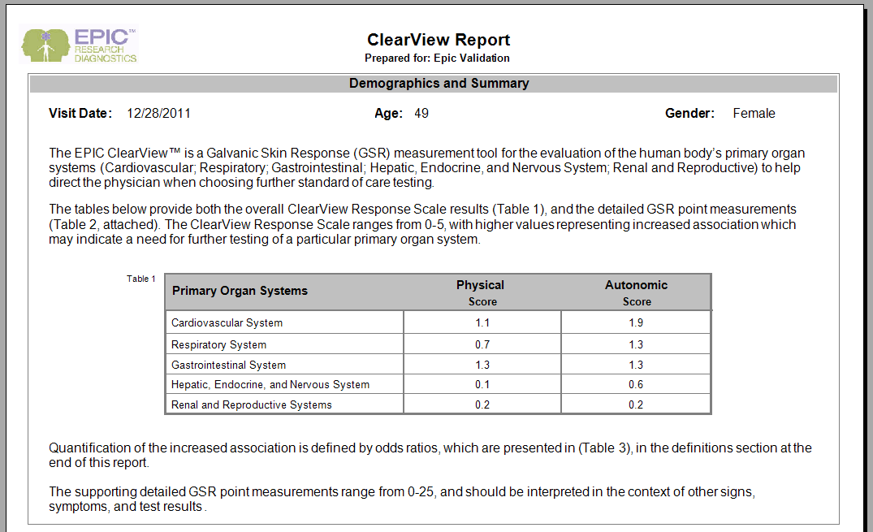

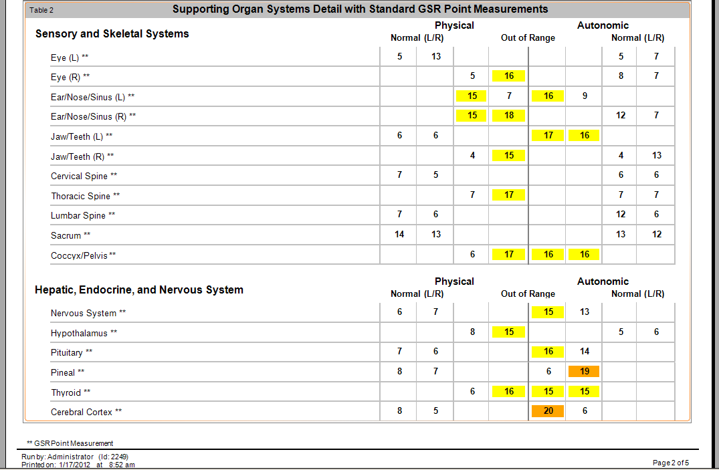
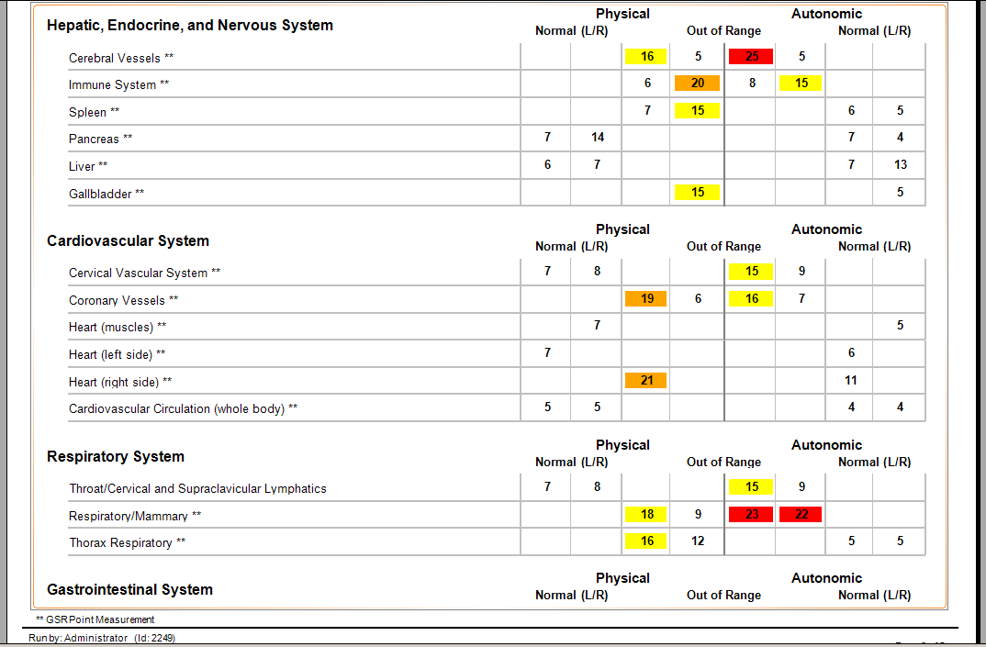
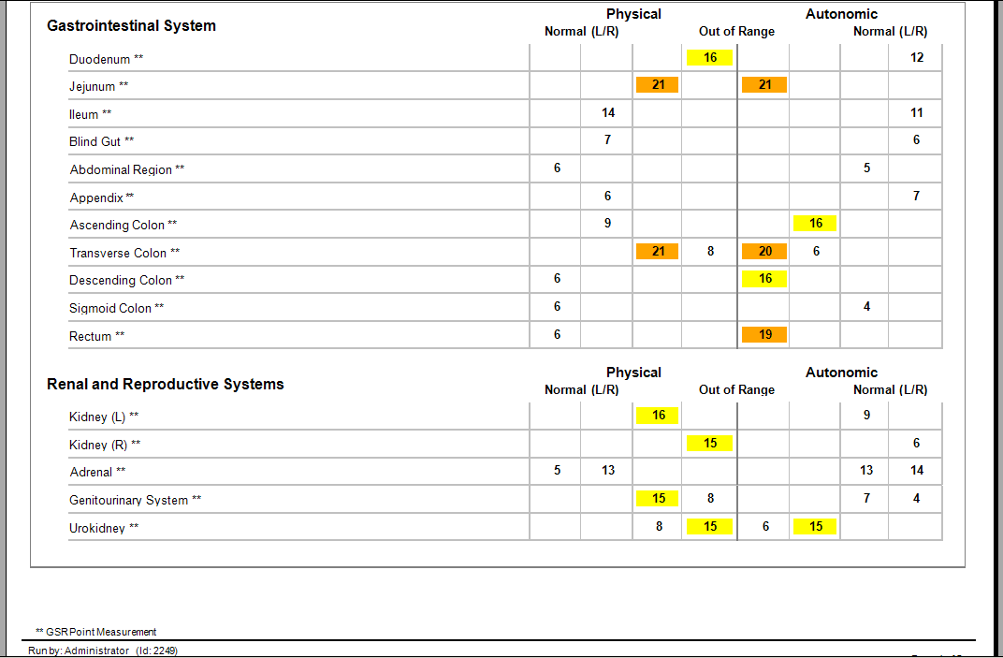
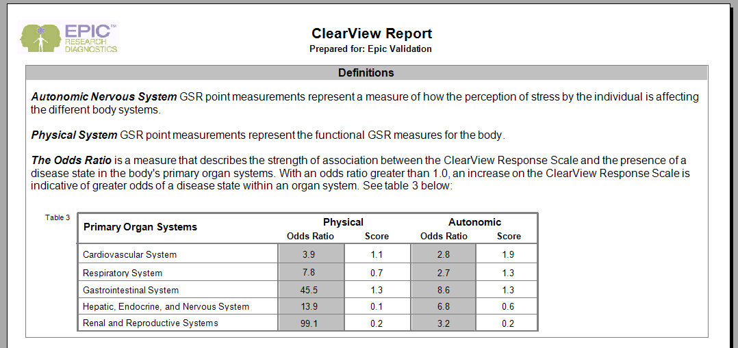

Verified Not Verified Non-Conformance Ref. No.

Click on the Print Report button which is located at the far left of the SAP Crystal Reports tab. Ensure that a local system printer is selected and click the “Print” button. Label the printout “AdminReport#1” and place your initials and date on the first page. Verify that the printout matches the values displayed on the screen.

Verified Not Verified Non-Conformance Ref. No.

Click on the Refresh button. Verify that the screen refreshes the report in the display area.

Verified Not Verified Non-Conformance Ref. No.

Click the right arrow button in order to advance the displayed report to the next page. Verify that the page is advanced and the next page of the report is displayed and continue advancing to the last page.

Verified Not Verified Non-Conformance Ref. No.

Click the left arrow button in order to return the displayed report to the previous page. Verify that the page returns to the previous page and continue until the first page of the report appears.

Verified Not Verified Non-Conformance Ref. No.

In the “Go to Page” entry field, type in “2” and enter. Verify that page 2 of the report is displayed. Repeat for pages 3, 4 and 5. In the “Go to Page” entry field, type in “1” and enter. Verify that page 1 of the report is displayed.

Verified Not Verified Non-Conformance Ref. No.

Click on the Find Text button. Verify that the Find Text dialog box opens. Type in “colon” and enter. Verify that the report advances to page 4 and a red rectangle surrounds Ascending Colon, and the Find Text dialog box remains open.

Verified Not Verified Non-Conformance Ref. No.

Click the Find Next button. Verify that a red rectangle surrounds Transverse Colon. Click the Find Next button. Verify that a red rectangle surrounds Descending Colon. Click the Find Next button. Verify that a red rectangle surrounds Sigmoid Colon.

Verified Not Verified Non-Conformance Ref. No.

Click the Find Next button. Verify that a dialog box opens with the message “Finished searching the document”. Click the OK button. Verify that the dialog box closes. In the Find Text dialog box, click the Cancel button. Verify that the dialog box closes. Click the Refresh button. Verify that the report returns to page 1 and the red rectangle disappears.

Verified Not Verified Non-Conformance Ref. No.

Click on the Zoom button. Select and click from the list the option to display Whole Page. Verify that the whole page of the report is displayed.

Verified Not Verified Non-Conformance Ref. No.

Click on the Zoom button. Select and click from the list the option to display 150%. Verify that only a portion of the first page of the report is displayed.

Verified Not Verified Non-Conformance Ref. No.

Report Scores
Click on the Search Capture button. Find Verification Subject1 Treatment ID 2191. Click View Capture. Resubmit for Analysis. Record the Treatment ID below:

Subject1

Print out the ClearView Report. Print out the ClearView Report for Treatment ID 2191. Compare the two reports and verify all data points match. Circle each data point that does not match. Sign and date the reports.

Verified Not Verified Non-Conformance Ref. No.

Verify the report scores are listed correctly on each of the two different reports per the following criteria:
-Any pair with both scores with a value of 14 or lower appears in the Normal (L/R) columns.
-Any pair with one or more scores of 15 or higher appears in the Out of Range columns.
-Scores displayed in the Out of Range columns with values from 15 through 18 are highlighted in yellow.
-Scores displayed in the Out of Range columns with values from 19 through 21 are highlighted in orange.
-Scores displayed in the Out of Range columns with values from 22 through 25 are highlighted in red.

Verified Not Verified Non-Conformance Ref. No.

Click on the Search Capture button. Find Verification Subject1 Treatment ID 2193. Click View Capture. Resubmit for Analysis. Record the Treatment ID below:

Subject2

Print out the ClearView Report. Print out the ClearView Report for Treatment ID 2193. Compare the two reports and verify all data points match. Circle each data point that does not match. Sign and date the reports.

Verified Not Verified Non-Conformance Ref. No.

Verify the report scores are listed correctly on each of the two different reports per the following criteria:
-Any pair with both scores with a value of 14 or lower appears in the Normal (L/R) columns.
-Any pair with one or more scores of 15 or higher appears in the Out of Range columns.
-Scores displayed in the Out of Range columns with values from 15 through 18 are highlighted in yellow.
-Scores displayed in the Out of Range columns with values from 19 through 21 are highlighted in orange.
-Scores displayed in the Out of Range columns with values from 22 through 25 are highlighted in red.

Verified Not Verified Non-Conformance Ref. No.

Click on the Search Capture button. Find Verification Subject1 Treatment ID 2197. Click View Capture. Resubmit for Analysis. Record the Treatment ID below:

Subject3

Print out the ClearView Report. Print out the ClearView Report for Treatment ID 2197. Compare the two reports and verify all data points match. Circle each data point that does not match. Sign and date the reports.

Verified Not Verified Non-Conformance Ref. No.

Verify the report scores are listed correctly on each of the two different reports per the following criteria:
-Any pair with both scores with a value of 14 or lower appears in the Normal (L/R) columns.
-Any pair with one or more scores of 15 or higher appears in the Out of Range columns.
-Scores displayed in the Out of Range columns with values from 15 through 18 are highlighted in yellow.
-Scores displayed in the Out of Range columns with values from 19 through 21 are highlighted in orange.
-Scores displayed in the Out of Range columns with values from 22 through 25 are highlighted in red.

Verified Not Verified Non-Conformance Ref. No.

Click the Exit button to exit ClearView. Attach the printed reports to the end of this protocol. Further validation of this tab will be conducted in a separate protocol.

  - User Login Verification

    - The EPIC User login does not have the same access to Admin pages. This section confirms the access restrictions for these users.

    - Double-click on the ClearView icon. Login as “EPICUser” with the password provided by the Network Administrator.

    - Click on the View Report button. Verify that the Report Menu is displayed and that “Analysis Report” is highlighted.

Verified Not Verified Non-Conformance Ref. No.

Click the Display Report button at the bottom right of the Report Menu box. Verify that the Search Capture window is displayed.

Verified Not Verified Non-Conformance Ref. No.

The Search Capture functionality for “New Capture” and “View Capture” has been previously validated. No further challenge for these buttons is required.

View Calibration button

Click on the View Calibration button. Verify that the Search Capture window remains open without further changes.

Verified Not Verified Non-Conformance Ref. No.

View Capture button

Click on the View Capture button. Verify that the Search Capture window remains open without further changes.

Verified Not Verified Non-Conformance Ref. No.

View Report button

Click on the View Calibration button. Verify that the Search Capture window remains open without further changes.

Verified Not Verified Non-Conformance Ref. No.

Export Data

Verify that the Export Data button is not displayed and/or available to the user.

Verified Not Verified Non-Conformance Ref. No.

    - Search for Epic O. Validation with Treatment ID 2185. Click View Report button. Verify that a report appears on the screen, that the Print Report tab for patient EPIC Validation is highlighted and the Print Report subtab is open.

Verified Not Verified Non-Conformance Ref. No.

Verify that the following tabs are listed in the gray bar just below the icons
Worksheet for Epic Validation
NS Analysis for Epic Validation
BioField Analysis for Epic Validation
Print Report for Epic Validation

Verified Not Verified Non-Conformance Ref. No.

    - Worksheet for Epic Validation tab (where Epic Validation is the patient name)

Click the Worksheet tab on the gray bar below the icons.
Verify that the table displayed on the right side of the tab has column headings of Organ, Physical Systems (both Left Hand and Right Hand) and an Autonomic Systems (both Left Hand and Right Hand) and that data (numbers) are present in the Physical System and Autonomic System table.

Verified Not Verified Non-Conformance Ref. No.

Verify that a listing of the Organ Systems is displayed on the left side of the tab. Verify that the Organ Systems listed have a check mark inside the box and that the systems listed are as follows:

Gastrointestinal System
Hepatic, Endocrine, and Nervous System
Sensory and Skeletal Systems
Cardiovascular System
Respiratory System
Renal and Reproductive Systems

Verified Not Verified Non-Conformance Ref. No.

Verify the Scan Details box appears below the Organ Systems box, and contains entries for Patient Name, Scan Date (including time), Software and Firmware. Click on the Search Capture button. Click the Find button in the Search Capture window. Locate and highlight Treatment ID 2185. Verify the Name, Scan Date, and Software highlighted match the entries in the Scan Details box. In the Search Capture window, locate and highlight the original scan (this is the ID listed in the Run Notes column next to Reprocessing of Treatment ID). Verify the Scan Date (including time) of the original scan matches the Scan Date (including time) of Treatment ID 2185. Verify the Firmware is listed as Revision E on the Worksheet tab.

Verified Not Verified Non-Conformance Ref. No.

Click the “Use color coding for organ systems” box just below the Organ Systems block. Verify that the names of the organ systems and organs are now color coded by system (i.e. Cardiovascular System is now gold in the Organ Systems box and Circulation, Coronary Vessels, Heart, etc., are also gold).

Verified Not Verified Non-Conformance Ref. No.

Click on each of the boxes in the Organ systems block to remove the check mark. Verify that there are no organs listed in the Physical and Autonomic System tables.

Verified Not Verified Non-Conformance Ref. No.

    - NS Analysis for Epic Validation tab (where Epic Validation is the patient name)

Click on the NS Analysis tab for “Epic Validation” in the gray bar below the icons. Verify that two boxes with a skeleton graphic is displayed surrounded with graph lines around each one.

Verified Not Verified Non-Conformance Ref. No.

Further verification of the displayed NS values will be conducted in a separate protocol.

    - Biofield Analysis for Epic Validation tab (where Epic Validation is the patient name)

Click on the Biofield Analysis for “Epic Validation” tab in the gray bar below the icons. Verify that three body images appear and the Item Data subtab is open, with boxes labeled “Indexes”, “Organ Systems” and “Settings”, and a Magnified View image box below.

Verified Not Verified Non-Conformance Ref. No.

Under Settings, click the button next to “Autonomic” to choose the “Unfiltered” system (Images without Capacitive Barrier). Click on each of the radio buttons to display different organ systems. Verify that the CT scans and portions of scan images change for each organ system. Document the verification in the table below by placing your initials in the appropriate column.

Organ | Verified Unfiltered | Non-Conforming? | Ref. No.
Skeletal System
Cardiovascular System
Small Intestine
Large Intestine
Renal & Reproductive System
Head & Upper Back
Lower Back
Immune System
Respiratory System
Nervous System

Repeat for the “Physical” or “Filtered” system (Images with Capacitive Barrier)

Organ | Verified Filtered | Non-Conforming? | Ref. No.
Skeletal System
Cardiovascular System
Small Intestine
Large Intestine
Renal & Reproductive System
Head & Upper Back
Lower Back
Immune System
Respiratory System
Nervous System

      - The same five samples selected in section 6.3.6.1 above will be used to verify the Biofield display. The previously printed ClearView Reports for these randomly selected individuals will be used in the verification. This data will be referred to as the Reference Data for subsequent steps.

NOTE: A sample size of 5 was selected as this verification is to ensure that the software is pulling data from the database accurately in a repeatable method. The data is not actually being calculated for display, but instead is being sourced from the database. The verification of the accuracy of the calculation will be documented in a separate validation protocol.

      - The reference data results will be compared to the Biofield Analysis report tab in the ClearView software. The data points compared for each samples are as follows:

        - Organ Systems- Compare each organ system listed on the Reference Data ClearView Report to ensure that the proper organs are listed in the Organ Systems section of the Biofield Analysis tab. This verification is done once as the systems are the same for all subjects.

        - Item Data- For each sample, verify the following:

        - Verify that the Physical and Autonomic reported values of Right Index and Left Index are displayed accurately for each organ within all organ systems.

NOTE: Several organs within the Skeletal Organ System are titled differently in the Biofield Analysis display. These structures include the shoulder, hip, knee and ankle. These were verified in the Admin view and cannot be compared here as the login does not provide the finger reference.

      - Verify that the Color Enhanced button when selected displays a color version of the biofield images displayed on the CT scans and in the Magnified View box on the left.

      - Verify that the B&W button when selected displays a black and white version of the biofield images displayed on the CT scans and in the Magnified View box on the left.

    - All verification steps will be recorded on the form located in Attachment C- Verification Record. Any discrepancies noted on the Verification Record. Appropriate investigation will be conducted and all discrepancies will be addressed in the final report with appropriate corrective and preventive action documented.

    - Verification that the Admin View is not available- The EPICUser login should not have access to the Admin View tab. Verify that the Admin tab cannot be opened and does not display an energized finger image.

Verified Not Verified Non-Conformance Ref. No.

    - Print Report for Epic Validation tab (where Epic Validation is the patient name)

Click on the Print Report tab for “Epic Validation” tab in the gray bar below the icons. Verify the “ClearView Report” appears and has the patient name, visit date, age and gender displayed at the top. Verify the five pages contain the descriptions and tables for data as shown in Section 6.3.10. Verify the Organ Systems groups contain the elements shown in the sample report. Verify the Physical and Autonomic (Normal and Out of Range) columns contain score data that consists of numbers from 0 thru 25, and some positions that are blank.

Verified Not Verified Non-Conformance Ref. No.

Click on the Print Report button. Ensure that a local system printer is selected and click the “Print” button. Label the printout “UserReport#2” and place your initials and date on the first page. Verify that the printout matches the values displayed on the screen.

Verified Not Verified Non-Conformance Ref. No.

Further validation of this tab will be conducted in a separate protocol. Click the “X” in the upper right corner until the ClearView main screen is displayed.

  - License File Test
As of the 1.1.0.0 version of ClearView, a license key mechanism was implemented into the product, and the software will not operate without a valid license file present. The ClearView software now looks at start up for a file named “ClearView.lic” to be located in the same folder as the ClearView application itself. This file is a plain text file containing an encrypted string that represents the actual license structure. There are three licenses; Full, CV (cardiovascular), and Basic. One of these three license files is copied into the ClearView folder and renamed as “ClearView.lic” to set the license.

    - CV License

The following procedure will copy the CV license file into the ClearView folder to verify the report functionality of the ClearView software with the CV license.

Click on the Exit Icon to exit ClearView. Click on My Computer and locate folder O:\QualitySystems\Quality_System_Documents\Non-quality_system_records\1.1.1.2_Validation. Locate and select the file “ClearViewCV.lic” to copy (CTRL-C).

Right click on the ClearView icon on the desktop and click on Properties. A Properties window will open. Navigate to the folder identified in the “Start in:” field, and copy the “ClearViewCV.lic” file into this folder (CTRL-V). Locate and delete the “ClearView.lic” file in the same folder. Rename the “ClearViewCV.lic” file to “ClearView.lic”. This has now installed the CV license file for the ClearView software.

    - CV License – Administrator Login – View Report

Double click the EPIC ClearView icon on the desktop. Click in the Username box and enter “Administrator”. Click in the password box and enter the password provided by the Network Administrator. The EPIC ClearView main screen is displayed.

Click the View Report icon. Type “V” in the last name box of the Search Capture box. Click Find. Highlight Epic O. Validation with Treatment ID 2185. Click View Report button. Verify that a report appears on the screen under Print Report tab for EPIC Validation.

Verified Not Verified Non-Conformance Ref. No.

Verify that the following tabs are listed in the gray bar just below the icons:
Worksheet for Epic Validation
NS Analysis for Epic Validation
Admin pages for Epic Validation
BioField Analysis for Epic Validation
Print Report for Epic Validation

Verified Not Verified Non-Conformance Ref. No.

CV License – Admin Login - Worksheet Tab
Click the Worksheet tab on the gray bar below the icons. Verify that the table displayed on the right side of the tab has column headings of Organ, Physical Systems (both Left Hand and Right Hand) and an Autonomic Systems (both Left Hand and Right Hand) and that data (numbers) are present in the Physical System and Autonomic System table.

Verified Not Verified Non-Conformance Ref. No.

Verify that a listing of the Organ Systems is displayed on the left side of the tab. Verify that the Organ Systems listed have a check mark inside the box and that the systems listed are as follows:

Cardiovascular
Respiratory
Gastrointestinal System
Renal and Reproductive Systems
Hepatic, Endocrine, and Nervous System

Verified Not Verified Non-Conformance Ref. No.

Click the “Use color coding for organ systems” box just below the Organ Systems block. Verify that the names of the organ systems and organs are now color coded by system (i.e. Cardiovascular System is now purple in the Organ Systems box and Circulation, Coronary Vessels, Heart, etc., are also purple).

Verified Not Verified Non-Conformance Ref. No.

Click on each of the boxes in the Organ systems block to remove the check mark. Verify that there are no organs listed in the Physical and Autonomic System tables.

Verified Not Verified Non-Conformance Ref. No.

Click to check the Cardiovascular box. Verify Cardiovascular is purple and the following organ names are purple in color and listed in the Physical and Autonomic System table:

Cardiovascular Circulation
Cervical Vascular System
Coronary Vessels
Heart – (muscles)
Heart – (Left Side)
Heart – (Right Side)
Thoracic Spine

Verified Not Verified Non-Conformance Ref. No.

Deselect the Cardiovascular box in the Organ Systems block. Click on the Respiratory box. Verify the Respiratory color is green and the following organ names are green in color and listed in the Physical and Autonomic System table:

Cervical Spine
Ear/Nose/Sinus (L)
Ear/Nose/Sinus (R)
Eye (L)
Eye (R)
Jaw/Teeth (L)
Jaw/Teeth (R)
Respiratory/Mammary
Thorax Respiratory

Verified Not Verified Non-Conformance Ref. No.

Deselect the Cardiovascular box in the Organ Systems block. Click to check the Gastrointestinal System box. Verify Gastrointestinal is red and the following organ names are red in color and listed in the Physical and Autonomic System table:

Abdominal Region
Appendix
Ascending Colon
Blind Gut
Descending Colon
Duodenum
Ileum
Jejunum
Lumbar Spine
Rectum
Sigmoid Colon
Transverse Colon

Verified Not Verified Non-Conformance Ref. No.

Deselect the Gastrointestinal box in the Organ Systems block. Click on the Renal and Reproductive box. Verify the Renal color is gold and that the following organs are gold in color and listed in the Physical and Autonomic System table:

Adrenal
Coccyx/Pelvis
Genitourinary System
Kidney – Left
Kidney – Right
Sacrum
Urokidney

Verified Not Verified Non-Conformance Ref. No.

Deselect the Renal and Reproductive box in the Organ Systems block. Click to check the Hepatic, Endocrine and Nervous System box. Verify Hepatic is blue and the following organ names are blue in color and listed in the Physical and Autonomic System table:

Cerebral Cortex
Cerebral Vessels
Gallbladder
Hypothalamus
Immune System
Liver
Nervous System
Pancreas
Pineal
Pituitary
Spleen
Thyroid

Verified Not Verified Non-Conformance Ref. No.

Click to check the Gastrointestinal, Hepatic, Sensory, Cardiovascular, Respiratory and Renal boxes. Verify that all boxes in the Organ System block are checked.

Verified Not Verified Non-Conformance Ref. No.

Verify that all organs are listed in the Physical and Autonomic System table and that all are properly color coded.

Verified Not Verified Non-Conformance Ref. No.

Click to uncheck the “Use color coding for organ systems” box below the Organ Systems block. Verify that all color coding has been removed.

Verified Not Verified Non-Conformance Ref. No.

CV License – Administrator Login – Print Report Tab
Click on the Print Report tab for “Epic Validation” tab in the gray bar below the icons. Verify the “ClearView Report” appears and has the patient name, visit date, age and gender displayed at the top. Verify the five pages contain the descriptions and tables for data as shown below. Verify the Organ Systems groups contain the elements shown in the sample report. Verify the Physical and Autonomic (Normal and Out of Range) columns contain score data that consists of numbers from 0 thru 5 (pages 1 and 5) and 0 thru 25 (pages 2, 3, and 4), and some positions that are blank.

Note: Report shown is for reference only.

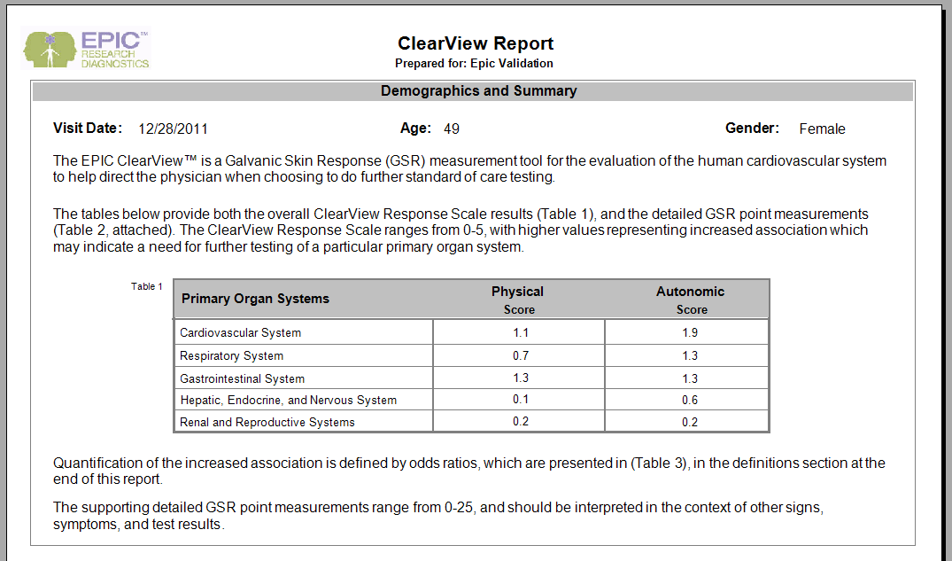
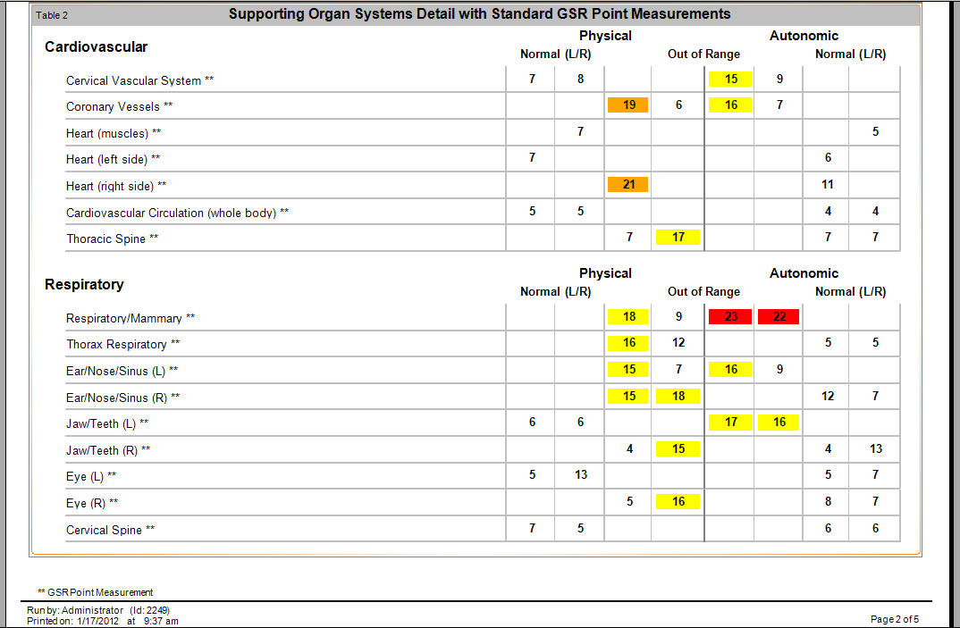
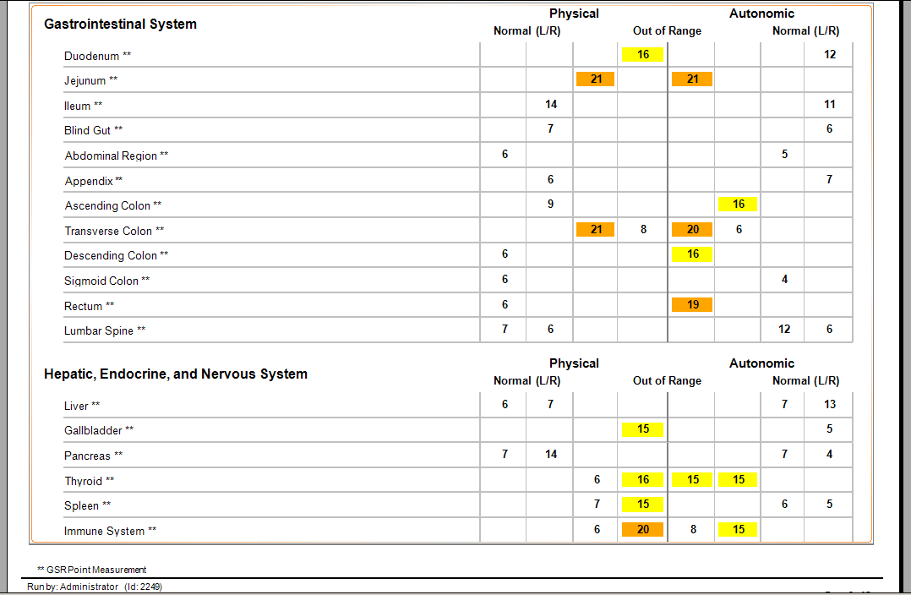
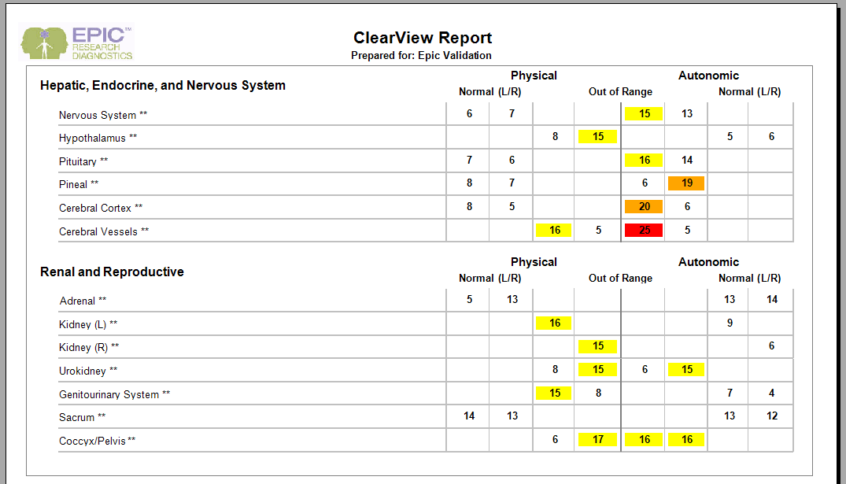

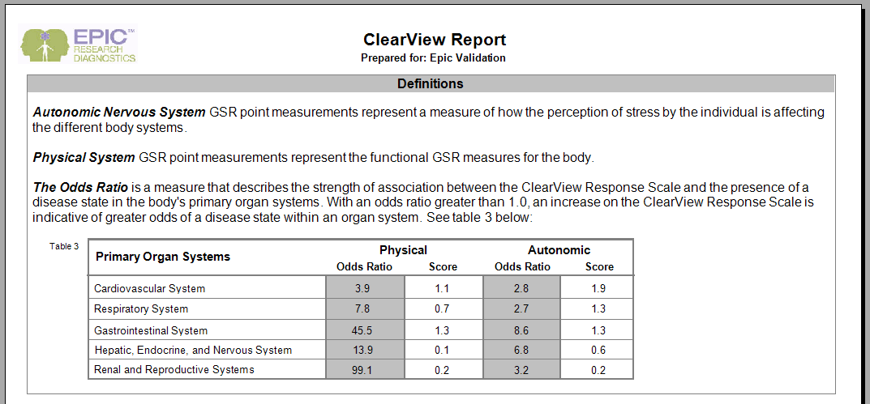

Verified Not Verified Non-Conformance Ref. No.

Click on the Print Report button which is located at the far left of the SAP Crystal Reports tab. Ensure that a local system printer is selected and click the “Print” button. Label the printout “CVReport#3” and place your initials and date on the first page. Verify that the printout matches the values displayed on the screen.

Verified Not Verified Non-Conformance Ref. No.

Click the “X” in the upper right corner of the screen until the ClearView main screen appears.

Report Scores
Click on the Search Capture button. Find Verification Subject1 Treatment ID 2191. Click View Capture. Resubmit for Analysis. Record the Treatment ID below:

Subject1

Print out the ClearView Report. Print out the ClearView Report for Treatment ID 2191. Compare the two reports and verify all data points match. Circle each data point that does not match. Sign and date the reports.

Verified Not Verified Non-Conformance Ref. No.

Verify the report scores are listed correctly on each of the two different reports per the following criteria:
-Any pair with both scores with a value of 14 or lower appears in the Normal (L/R) columns.
-Any pair with one or more scores of 15 or higher appears in the Out of Range columns.
-Scores displayed in the Out of Range columns with values from 15 through 18 are highlighted in yellow.
-Scores displayed in the Out of Range columns with values from 19 through 21 are highlighted in orange.
-Scores displayed in the Out of Range columns with values from 22 through 25 are highlighted in red.

Verified Not Verified Non-Conformance Ref. No.

Click on the Search Capture button. Find Verification Subject1 Treatment ID 2193. Click View Capture. Resubmit for Analysis. Record the Treatment ID below:

Subject2

Print out the ClearView Report. Print out the ClearView Report for Treatment ID 2193. Compare the two reports and verify all data points match. Circle each data point that does not match. Sign and date the reports.

Verified Not Verified Non-Conformance Ref. No.

Verify the report scores are listed correctly on each of the two different reports per the following criteria:
-Any pair with both scores with a value of 14 or lower appears in the Normal (L/R) columns.
-Any pair with one or more scores of 15 or higher appears in the Out of Range columns.
-Scores displayed in the Out of Range columns with values from 15 through 18 are highlighted in yellow.
-Scores displayed in the Out of Range columns with values from 19 through 21 are highlighted in orange.
-Scores displayed in the Out of Range columns with values from 22 through 25 are highlighted in red.

Verified Not Verified Non-Conformance Ref. No.

Click on the Search Capture button. Find Verification Subject1 Treatment ID 2197. Click View Capture. Resubmit for Analysis. Record the Treatment ID below:

Subject3

Print out the ClearView Report. Print out the ClearView Report for Treatment ID 2197. Compare the two reports and verify all data points match. Circle each data point that does not match. Sign and date the reports.

Verified Not Verified Non-Conformance Ref. No.

Verify the report scores are listed correctly on each of the two different reports per the following criteria:
-Any pair with both scores with a value of 14 or lower appears in the Normal (L/R) columns.
-Any pair with one or more scores of 15 or higher appears in the Out of Range columns.
-Scores displayed in the Out of Range columns with values from 15 through 18 are highlighted in yellow.
-Scores displayed in the Out of Range columns with values from 19 through 21 are highlighted in orange.
-Scores displayed in the Out of Range columns with values from 22 through 25 are highlighted in red.

Verified Not Verified Non-Conformance Ref. No.

Click the Exit button to exit ClearView. Attach the printed reports to the end of this protocol.

    - CV License – User Login – View Report

Double click the EPIC ClearView icon on the desktop. Click in the Username box and enter “EPICUser”. Click in the password box and enter the password provided by the Network Administrator. The EPIC ClearView main screen is displayed.

Click the View Report icon. Type “V” in the last name box of the Search Capture box. Click Find. Highlight Epic O. Validation with Treatment ID 2185. Click View Report button. Verify that a report appears on the screen under Print Report tab for EPIC Validation.

Verified Not Verified Non-Conformance Ref. No.

Verify that the following tabs are listed in the gray bar just below the icons:
Worksheet for Epic Validation
NS Analysis for Epic Validation
BioField Analysis for Epic Validation
Print Report for Epic Validation

Verified Not Verified Non-Conformance Ref. No.

CV License – User Login - Worksheet Tab
Click the Worksheet tab on the gray bar below the icons. Verify that the table displayed on the right side of the tab has column headings of Organ, Physical Systems (both Left Hand and Right Hand) and an Autonomic Systems (both Left Hand and Right Hand) and that data (numbers) are present in the Physical System and Autonomic System table.

Verified Not Verified Non-Conformance Ref. No.

Verify that a listing of the Organ Systems is displayed on the left side of the tab. Verify that the Organ Systems listed have a check mark inside the box and that the systems listed are as follows:

Cardiovascular
Respiratory
Gastrointestinal System
Renal and Reproductive Systems
Hepatic, Endocrine, and Nervous System

Verified Not Verified Non-Conformance Ref. No.

Click the “Use color coding for organ systems” box just below the Organ Systems block. Verify that the names of the organ systems and organs are now color coded by system (i.e. Cardiovascular System is now purple in the Organ Systems box and Circulation, Coronary Vessels, Heart, etc., are also purple).

Verified Not Verified Non-Conformance Ref. No.

Click on each of the boxes in the Organ systems block to remove the check mark. Verify that there are no organs listed in the Physical and Autonomic System tables.

Verified Not Verified Non-Conformance Ref. No.

Click to check the Cardiovascular box. Verify Cardiovascular is purple and the following organ names are purple in color and listed in the Physical and Autonomic System table:

Cardiovascular Circulation
Cervical Vascular System
Coronary Vessels
Heart – (muscles)
Heart – (Left Side)
Heart – (Right Side)
Thoracic Spine

Verified Not Verified Non-Conformance Ref. No.

Deselect the Cardiovascular box in the Organ Systems block. Click on the Respiratory box. Verify the Respiratory color is green and the following organ names are green in color and listed in the Physical and Autonomic System table:

Cervical Spine
Ear/Nose/Sinus (L)
Ear/Nose/Sinus (R)
Eye (L)
Eye (R)
Jaw/Teeth (L)
Jaw/Teeth (R)
Respiratory/Mammary
Thorax Respiratory

Verified Not Verified Non-Conformance Ref. No.

Deselect the Cardiovascular box in the Organ Systems block. Click to check the Gastrointestinal System box. Verify Gastrointestinal is red and the following organ names are red in color and listed in the Physical and Autonomic System table:

Abdominal Region
Appendix
Ascending Colon
Blind Gut
Descending Colon
Duodenum
Ileum
Jejunum
Lumbar Spine
Rectum
Sigmoid Colon
Transverse Colon

Verified Not Verified Non-Conformance Ref. No.

Deselect the Gastrointestinal box in the Organ Systems block. Click on the Renal and Reproductive box. Verify the Renal color is gold and that the following organs are gold in color and listed in the Physical and Autonomic System table:

Adrenal
Coccyx/Pelvis
Genitourinary System
Kidney – Left
Kidney – Right
Sacrum
Urokidney

Verified Not Verified Non-Conformance Ref. No.

Deselect the Renal and Reproductive box in the Organ Systems block. Click to check the Hepatic, Endocrine and Nervous System box. Verify Hepatic is blue and the following organ names are blue in color and listed in the Physical and Autonomic System table:

Cerebral Cortex
Cerebral Vessels
Gallbladder
Hypothalamus
Immune System
Liver
Nervous System
Pancreas
Pineal
Pituitary
Spleen
Thyroid

Verified Not Verified Non-Conformance Ref. No.

Click to check the Gastrointestinal, Hepatic, Sensory, Cardiovascular, Respiratory and Renal boxes. Verify that all boxes in the Organ System block are checked.

Verified Not Verified Non-Conformance Ref. No.

Verify that all organs are listed in the Physical and Autonomic System table and that all are properly color coded.

Verified Not Verified Non-Conformance Ref. No.

Click to uncheck the “Use color coding for organ systems” box below the Organ Systems block. Verify that all color coding has been removed.

Verified Not Verified Non-Conformance Ref. No.

CV License – User Login – Print Report Tab
Click on the Print Report tab for “Epic Validation” tab in the gray bar below the icons. Verify the “ClearView Report” appears and has the patient name, visit date, age and gender displayed at the top. Verify the five pages contain the descriptions and tables for data as shown in Section 6.7.3. Verify the Organ Systems groups contain the elements shown in the sample report. Verify the Physical and Autonomic (Normal and Out of Range) columns contain score data that consists of numbers from 0 thru 25, and some positions that are blank.

Verified Not Verified Non-Conformance Ref. No.

Click on the Print Report button which is located at the far left of the SAP Crystal Reports tab. Ensure that a local system printer is selected and click the “Print” button. Label the printout “CVReport#4” and place your initials and date on the first page. Verify that the printout matches the values displayed on the screen.

Verified Not Verified Non-Conformance Ref. No.

Click the “X” in the upper right corner until the ClearView main screen is displayed.

    - Basic License

The following procedure will copy the basic license file into the ClearView folder to verify the report functionality of the ClearView software with the basic license.

Click on the Exit Icon to exit ClearView. Click on My Computer and locate folder O:\QualitySystems\Quality_System_Documents\Non-quality_system_records\1.1.1.2_Validation. Locate and select the file “ClearViewBasic.lic” to copy (CTRL-C).

Right click on the ClearView icon on the desktop and click on Properties. A Properties window will open. Navigate to the folder identified in the “Start in:” field, and copy the “ClearViewBasic.lic” file into this folder (CTRL-V). Locate and delete the “ClearView.lic” file in the same folder. Rename the “ClearViewBasic.lic” file to “ClearView.lic”. This has now installed the basic license file for the ClearView software.

Basic License - Administrator Login - Print Report Tab
Double click the EPIC ClearView icon on the desktop. Click in the Username box and enter “Administrator”. Click in the password box and enter the password provided by the Network Administrator. The EPIC ClearView main screen is displayed.

Click the View Report icon. Type “V” in the last name box of the Search Capture box. Click Find. Highlight Epic O. Validation with Treatment ID 2185. Click View Report button. Verify that a report appears on the screen under Print Report tab for EPIC Validation.

Verified Not Verified Non-Conformance Ref. No.

Verify that the only tab available is the Print Report tab. Verify that the report displays as shown below with columns for Measurement Point with finger descriptions, Left and Right Physical and Left and Right Autonomic scores. The Measurement Point column should consist of rows labeled Thumb #1 thru Thumb #8, Index #1 thru Index #12, Middle #1 thru Middle #9, Ring #1 thru Ring #9, and Pinky #1 thru Pinky #9. The scores data should consist of numbers from 0 thru 25, and some positions that are blank.

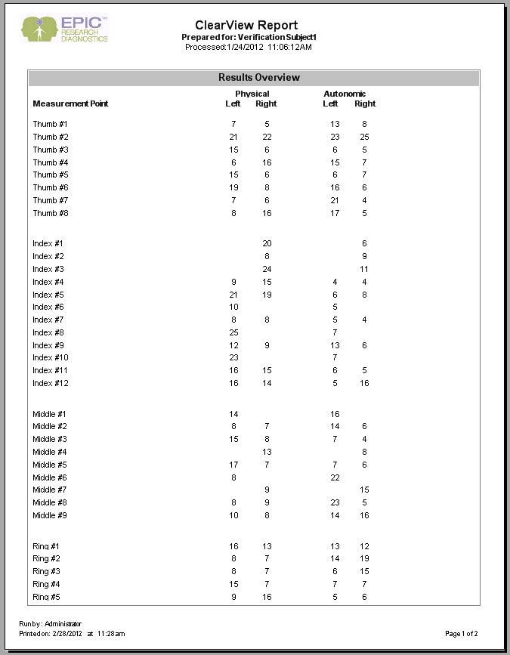
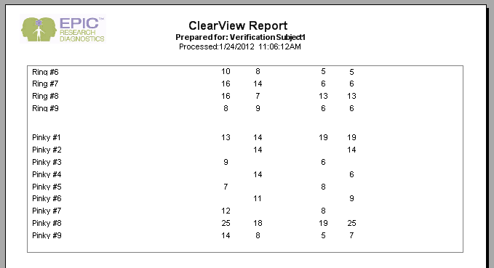

Report shown is for reference only, score values will be different.

Verified Not Verified Non-Conformance Ref. No.

Click on the Print Report button. Ensure that a local system printer is selected and click the “Print” button. Label the printout “BasicReport#5” and place your initials and date on the first page. Verify that the printout matches the values displayed on the screen.

Verified Not Verified Non-Conformance Ref. No.

Basic License – User Login - Print Report Tab
Click the “X” at the far right of the Print Report subtab to return to the ClearView main screen. Click the Exit icon. Verify that the ClearView software closes and the desktop appears. Double click the EPIC ClearView icon on the desktop. Click in the Username box and enter “EPICUser”. Click in the password box and enter the password provided by the Network Administrator. The EPIC ClearView main screen is displayed.

Verified Not Verified Non-Conformance Ref. No.

Click the View Report icon. Type “V” in the last name box of the Search Capture box. Click Find. Highlight Epic O. Validation with Treatment ID 2185. Click View Report button. Verify that a report appears on the screen under Print Report tab for EPIC Validation.

Verified Not Verified Non-Conformance Ref. No.

Verify that the only tab available is the Print Report tab. Verify that the report displays as shown in previous section with columns for Measurement Point with finger descriptions, Left and Right Physical and Left and Right Autonomic scores. The Measurement Point column should consist of rows labeled Thumb #1 thru Thumb #8, Index #1 thru Index #12, Middle #1 thru Middle #9, Ring #1 thru Ring #9, and Pinky #1 thru Pinky #9. The scores data should consist of numbers from 0 thru 25, and some positions that are blank. Report shown is for reference only, score values will be different.

Verified Not Verified Non-Conformance Ref. No.

Click on the Print Report button. Ensure that a local system printer is selected and click the “Print” button. Label the printout “BasicReport#6” and place your initials and date on the first page. Verify that the printout matches the values displayed on the screen, and the values from BasicReport#5.

Verified Not Verified Non-Conformance Ref. No.

    - Restore Full License

The following procedure will copy the full license file into the ClearView folder to verify the full report functionality of the ClearView software has been restored.

Click the “X” in the upper right corner of the report tab to return to the ClearView main screen. Click on the Exit Icon to exit ClearView. Click on My Computer and locate folder O:\QualitySystems\Quality_System_Documents\Non-quality_system_records\1.1.1.2_Validation. Locate and select the file “ClearViewFull.lic” to copy (CTRL-C).

Right click on the ClearView icon on the desktop and click on Properties. A Properties window will open. Navigate to the folder identified in the “Start in:” field, and copy the “ClearViewFull.lic” file into this folder (CTRL-V). Locate and delete the “ClearView.lic” file in the same folder. Rename the “ClearViewFull.lic” file to “ClearView.lic”. This has now installed the full license file for the ClearView software.

Double click the EPIC ClearView icon on the desktop. Click in the Username box and enter “Administrator”. Click in the password box and enter the password provided by the Network Administrator. The EPIC ClearView main screen is displayed.

Click the View Report icon. Type “Epic” in the first name box of the Search Capture box. Click Find. Highlight Epic O. Validation with Treatment ID 2185. Click View Report button. Verify that a report appears on the screen under the Print Report tab for EPIC Validation.

Verified Not Verified Non-Conformance Ref. No.

Click on the Print Report button. Ensure that a local system printer is selected and click the “Print” button. Label the printout “FullReport#7” and place your initials and date on the first page. Verify that the printout matches the values displayed on the screen.

Verified Not Verified Non-Conformance Ref. No.

Verify that the following tabs are listed in the gray bar just below the icons:
Worksheet for Epic Validation
NS Analysis for Epic Validation
Admin pages for Epic Validation
BioField Analysis for Epic Validation
Print Report for Epic Validation

Verified Not Verified Non-Conformance Ref. No.

Verify that when the Admin Pages tab is highlighted, five subtabs as listed below are visible:
Raw Data (open)
Raw Report Data
Images without Capacitive Barrier
Images with Capacitive Barrier
Calibration Data

Verified Not Verified Non-Conformance Ref. No.

- Reference

EG-011, Software Validation
QA-004, Deviations

- Attachments

Attachment A, Deviations from Protocol
Attachment B, Non-conformances Worksheet
Attachment C, Verification Record

Attachment A
Deviations from Protocol
NOTE: This form is used for minor deviations from the protocol as written. Fill out all sections of this form prior to moving forward in the validation process.

No. | Date | Name | Description of Deviation (include reference to the protocol section) | Resolution/Action Taken | Reviewed

Attachment B
Non-conformances Worksheet
NOTE: This form is used for all protocol steps which did not perform as expected. Fill out all sections of this form prior to moving forward in the validation process.
No. | Date | Name | Description of Non-conformance (include reference to the protocol section) | Resolution/Action Taken

Attachment C
Biofield Verification Record
Organ Systems
System | Verified? |  | System | Verified? |  | System | Verified?
 | Admin | User |  | Admin | User |  | Admin | User
Skeletal System |  |  | Cardiovascular System |  |  | Small Intestine
Large Intestine |  |  | Renal & Reproductive System |  |  | Head & Upper Back
Lower Back |  |  | Immune System |  |  | Respiratory System
Nervous System

Item Data
Sample | Physical |  | Autonomic |  |  | Color |  |  | B&W |  |  | Sector/ Organ Verify | Admin View Verify
Sample | Right Index | Left Index | Right Index | Left Index |  |  | Auto | Phys | Auto | Phys |  | Sector/ Organ Verify | Admin View Verify
A - Admin
B - Admin
C - Admin
D - Admin
E - Admin
A - User
B - User
C - User
D - User
E - User
Verification of the Correct Biofield to the Image Displayed
Signature: |  |  |  |  | Title: |  |  |  |  |  | Date:

